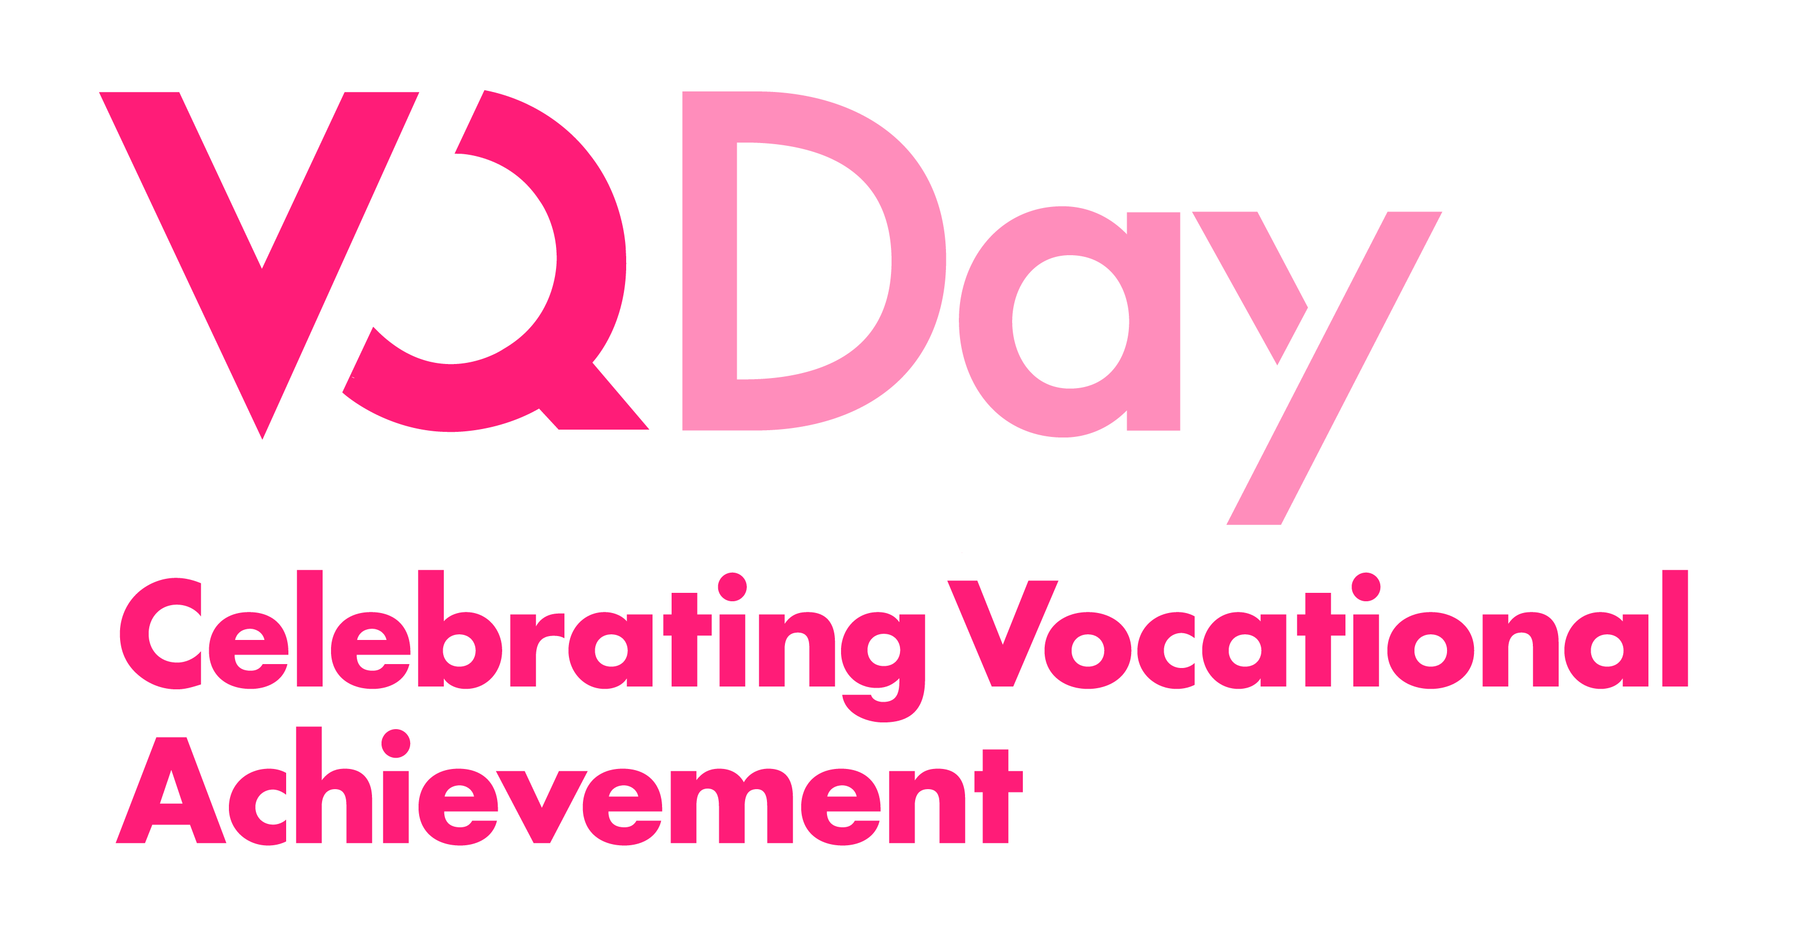
Instructions on how to create your own personalised VQ Day message
The 8th annual celebration of vocational achievement, VQ Day, takes place on Wednesday 10th June 2015. To mark the occasion, the Government wants to say thank you and well done to those who have worked hard to achieve a vocational qualification over the last year and wish those who are still studying the best of luck.
Julie James has given VQ Day her full support by producing a congratulatory video message for VQ learners and we need your help to distribute the video to your learners on Wednesday 10th June 2015 (VQ Day).
All you will have to do is fill in a simple template to personalise your page, where the Minister’s video message will also appear. Once complete, the template will create a webpage tailored for your organisation. You will then be able to email a link to all those who have achieved, or are still studying, for a vocational qualification.
How do I get started?
To celebrate the achievements of your vocational learners and receive your own VQ Day website page with the Minister’s video, all you need to do is follow the six steps below.
- Visit www.vqday.org.uk/providerswales to fill in a simple template. The template allows you to include a message specifically for your learners
- Please enter the password: edge
- Enter your learning institution’s information
- The name of the company as you wish it to appear
- A contact email address for the person who will be sent the finished page (N.B. this will not appear on the page)
- There is the option to include an image for the establishment. To do this, the image needs to be a .jpg format and less than 1MB in file size
- Finally, enter your own thank you message to accompany the message. This is the area for you to congratulate your students and deliver a message that will be displayed along with the video (please see an example below, which you can use should you wish to).
- Once the above page is submitted successfully you will see a thank you page
- Once your page has been approved you will receive an email to the address that you provided letting you know that your page is live. It will contain a link to the page that you will then be able to distribute accordingly. Don’t forget to check your junk folder just in case!
- Send the link to your learners on VQ Day itself Wednesday 10th June

If you want to make any changes to your page or have any questions, please contact the VQ Day team by emailing aribenfors@edge.co.uk or by phoning 0207 960 1540.
Thank you for joining in with this year’s VQ Day celebrations!
VQ Day page example
Click here to see how it will look
Name of college, school or learning provider
Test name
Email
Test@test.ac.uk
Image
Test.jpg
Description
Today is VQ Day 2015 - a day to celebrate vocational achievement.
INSERT NAME OF COLLEGE OR LEARNING PROVIDER, would like to say well done for working so hard towards your vocational qualification this year.
Vocational qualifications have never been more important to the economy and to helping you get a job. High quality vocational courses, like the one you have worked for, deliver the trained, talented employees businesses are crying out for.
It’s not just us that want to say well done, thank you and best of luck for the future, it’s also the Government. Like us, the Government knows how important hands-on learning is, which is why the Deputy Minister for Skills and Technology, Julie James, has videoed a special message for all vocational learners this year. You can watch the video below.
Your hard work means that you should be as proud of your achievements as we are. That is why we want you to share this message with your friends and family so they know how important the qualification you have worked for is – not only to you but to the country as a whole.
Well done on everything you have worked for this year and best of luck with the rest of your studies or with putting in practice what you’ve learnt.
INSERT NAME OF COLLEGE OR LEARNING PROVIDER, PRINCIPAL/DIRECTOR

